**DAILY ONLINE ACTIVITIES SUMMARY**

|  |  |  |  |  |  |  |  |  |
| --- | --- | --- | --- | --- | --- | --- | --- | --- |
| **Date:** | 12-06-2020 | | | | | **Name:** | K S Prajwal | |
| **Sem & Sec** | IV A sec | | | | | **USN:** | 4AL18CS032 | |
| **Online Test Summary** | | | | | | | | |
| **Subject** | | Aadalitha Kannada | | | | | | |
| **Max. Marks** | | 25 | | **Score** | | | 22 | |
| **Certification Course Summary** | | | | | | | | |
| **Course** | Face Recognition with Deep Learning using Python | | | | | | | |
| **Certificate Provider** | | | Udemy | | **Duration** | | | **3 hr** |
| **Coding Challenges** | | | | | | | | |
| **Problem Statement:**  1: Program to find the longest repeating sequence in a string  2: Program to swap two numbers using friend as a bridge concept. | | | | | | | | |
| **Status:** completed | | | | | | | | |
| **Uploaded the report in Github** | | | | | yes | | | |
| **If yes Repository name** | | | | | <https://github.com/alvas-education-foundation/KS_Prajwal> | | | |
| **Uploaded the report in slack** | | | | | yes | | | |

Online Test Details: (Attach the snapshot and briefly write the report for the same)

Certification Course Details: (Attach the snapshot and briefly write the report for the same)

Coding Challenges Details: (Attach the snapshot and briefly write the report for the same)

**Online Test Details:** It was from all the chapters and the test was for 25 minutes having 25 question all multiple-choice question. The questions were simple and optimal and the score that I got was 22/25

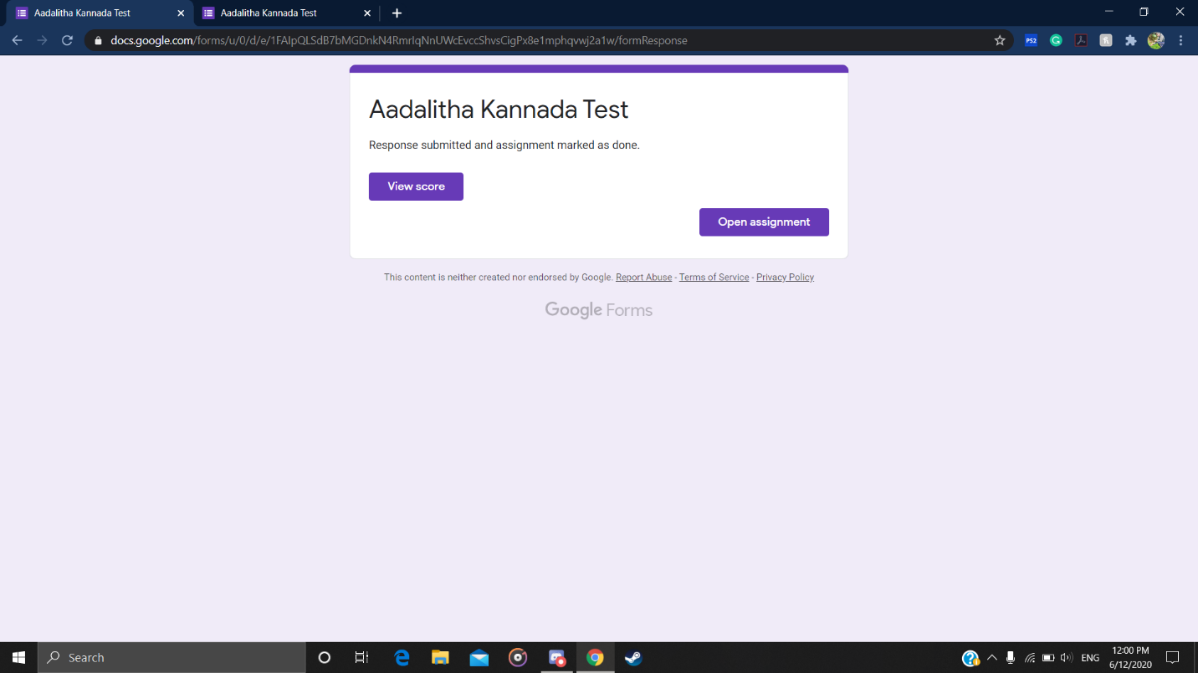

Snapshot of certification course: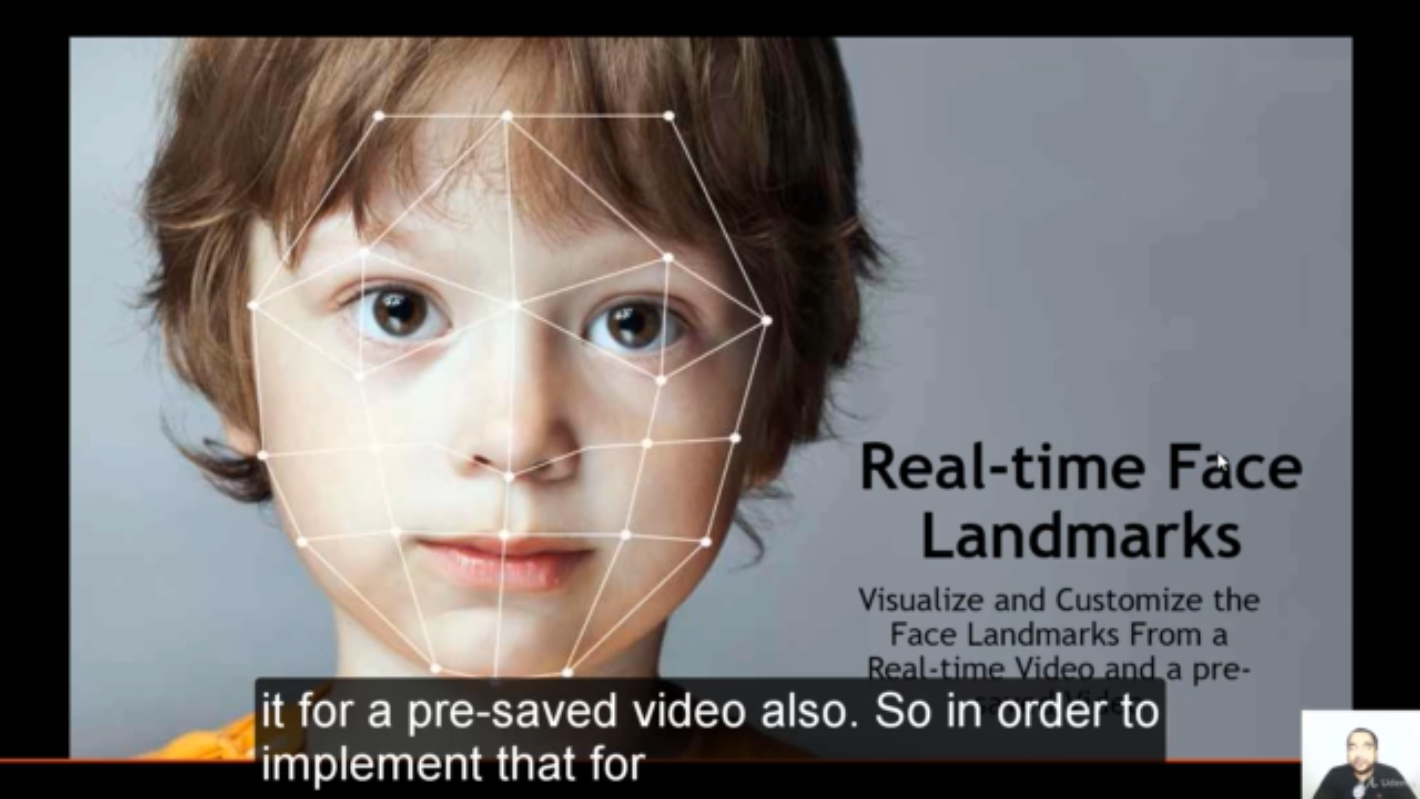

It showed how to do real time face mark in video and through the web cam and applying makeup on it

**Online coding:**

Problem 1: (using java) Program to find the longest repeating sequence in a string

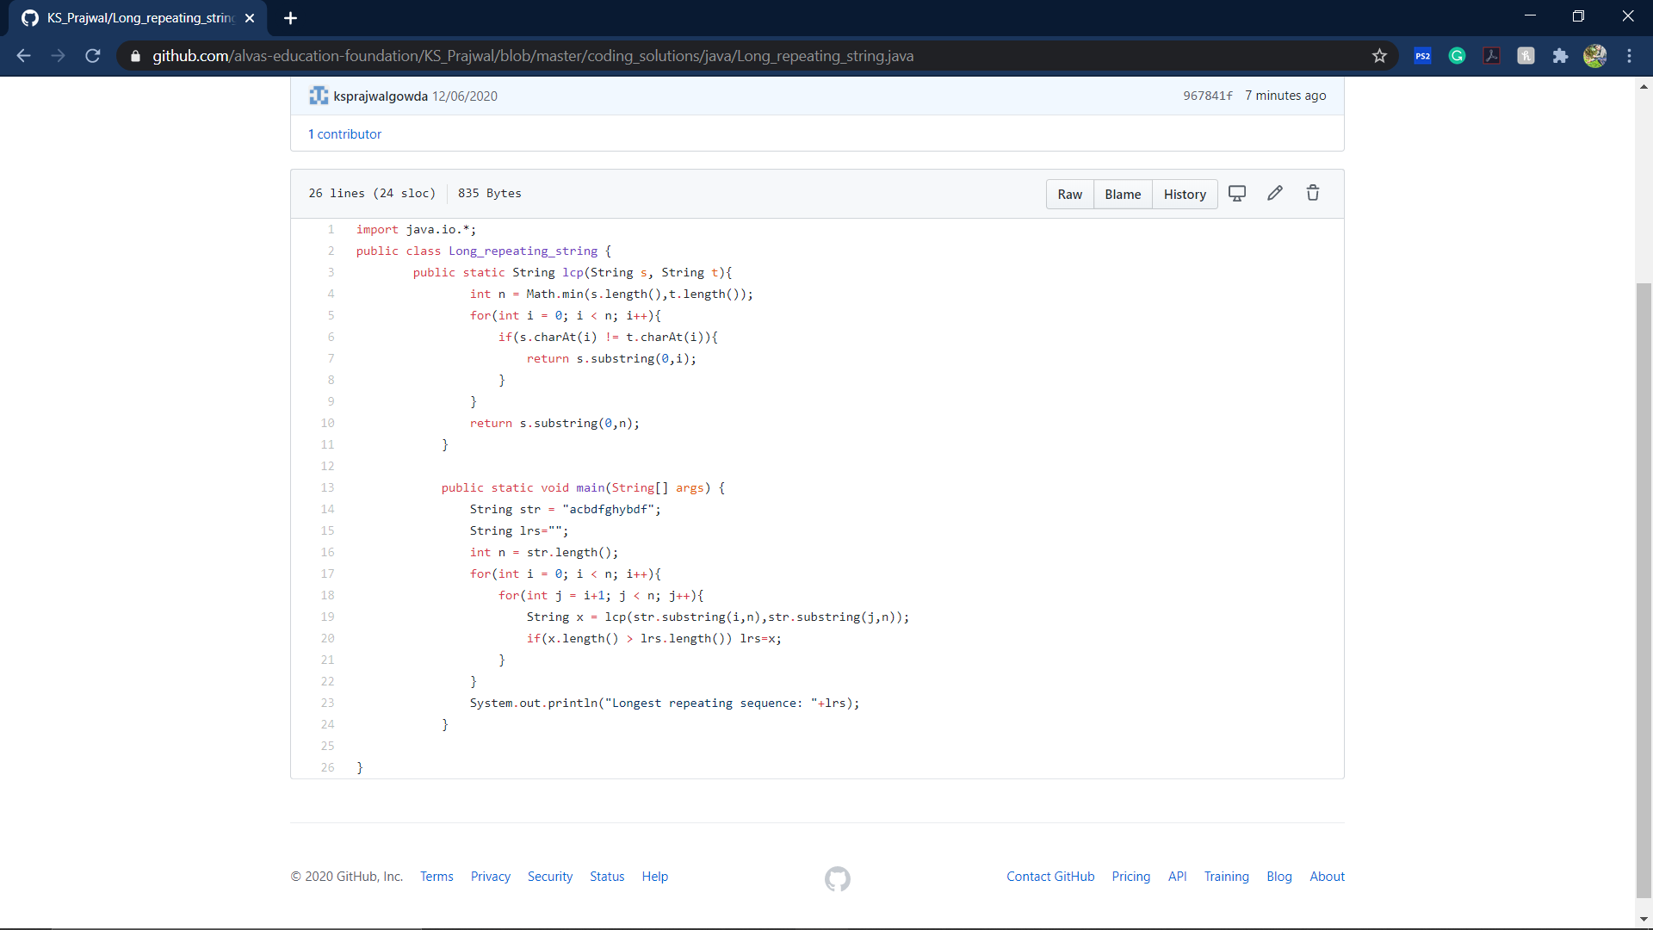

Problem 2: (using C++) Program to swap two numbers using friend as a bridge concept.

